initial

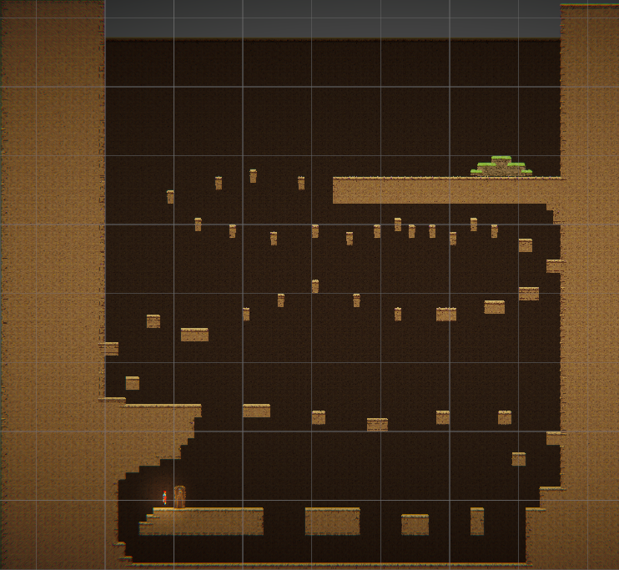pros

most jumps are possible!

no falling into endless pits

no softlocks probably

level is hard, as per the design

ngl I didn't even realise as I was making it but theres a part that catches you if you fall (more of this would be good, soft checkpoints are good game design for this kind of level)

cons

level is hard, as per design, therefore its hard to playtest certain areas without checkpointing

last low ceiling jump is literally impossible

level design is a bit bland at the start, all same Y level jumps

second/first iteration

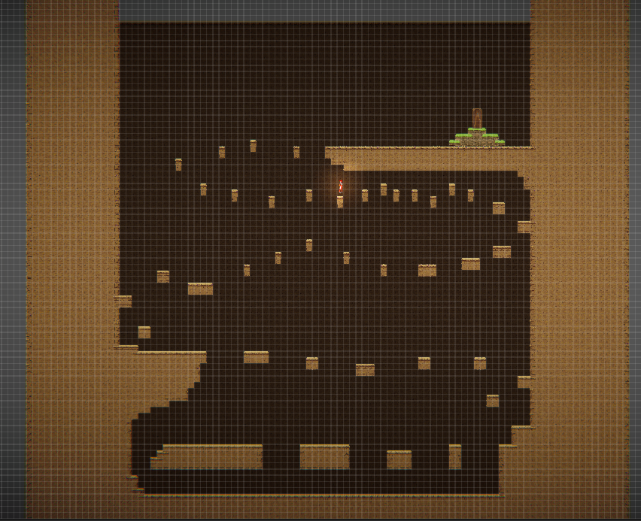

I fixed the unmakeable jump but the low ceiling part annoying, fix this? or keep the difficulty?

I’ll tweak it a bit

lets add another few sections shall we?

Third iteration

­­­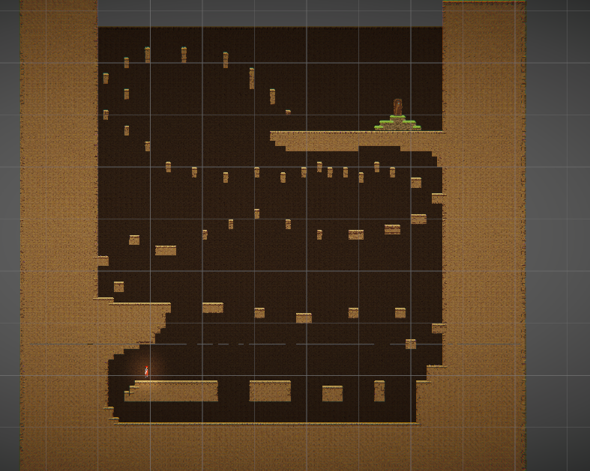added a final section

Feedback

Were there any parts of the level you found particularly frustrating or unforgiving, if so, which parts?

-

The second series of platforms were difficult and had multiple jumps missed by very narrow margin.

Were you able to find your way through the level?

-

No, only made it to third series of platforms a few times and failed.

Did the jumps on the thin platforms successfully elevate the tension?

-

Yes.

Did you find any parts of the level that seemed out of place, or otherwise needing improvement?

-

The walk back after falling is boring compared to the platforming.

Were you able to adapt to the sections you found difficult after a few attempts?

-

Not very well.

If you reached the end, or otherwise finished a hard segment, how did it feel?

-

n/a.

Any other comments?

-

The map seems interesting but I could not see it all in game.

1, intentional design but I also thought the jumps missed by narrow margin was a bland section that needed some spice  
2, skill issue (jk, but it sounds like the message of “go up” was transferred to the player, so that is a success)

3, YAY

4, tbh the walk back after the fall (im assuming its that bottom floor section) had 0 thought to it, its purely a softlock prevention method  
5, oh, I guess I should tweak a few of the jumps

6, n/a

7, yay, unfortunately that’s how these kinds of games go sometimes